# Appendix A - Billing and Response File Formats

The Ontario Ministry of Health and Long-Term Care (MoH for our purposes) has the responsibility for establishing and maintaining the Ontario Health Insurance Plan (OHIP) Schedule of Benefits and Fees. You can find the current version of the OHIP Fee Schedule Master at this site: <http://www.health.gov.on.ca/en/pro/programs/ohip/sob/>

Two key resources at the above website are the **Text Format version of the OHIP Fee Schedule Master** (we’ll refer to this as ‘Master’) and the PDF document entitled **‘OHIP Fee Schedule Master Record Layout’**. These two files are the most important for us as developers on the EMS project, However the document entitled **’Physician Services Under the Health Insurance Act’** explains all the billable procedures in much more detail (refer to it for interest’ sake – you’re not responsible for this 746pg document!).

In the Master text file, we might encounter a line such as:

A66520120401999999990000000000000000000000000009135000000000000000000000000

**What does this mean? Refer to the Master Record Layout:**

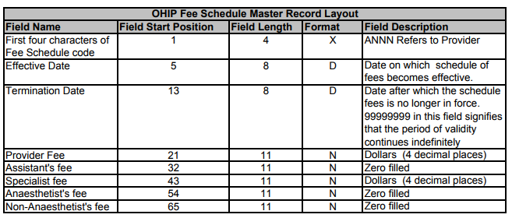

We see that the Fee code is A665 (which is a Prenatal Consultation according to the 746pg. document), it was effective from April 1, 2012 (YYYYMMDD) and continues indefinitely (e.g. the MoH is not suspending payments anytime soon for this service!).

Lastly, we see that there is a Specialist fee of $91.35 paid for this service.

For our purposes in EMS-1, the Master file will be similar to the above, but truncated. The data for the line above would instead be carried as:

A6652012040100000913500

In this case, we’re carrying the Schedule Code (or Fee Code), the effective date as YYYYMMDD and 11 digits for the dollar amount paid for the service.

**What does the Billing File look like?**

First, we’ll review the perquisites for creating a Billing File.

1. A Billing File covers all billable procedures for a given calendar month (e.g. Nov 1 to Nov 30).
2. Physicians would normally have been entering billing codes into the EMS-I system after seeing the patients, so you will have data stored for each appointment in the month that indicates which billing codes apply to that appointment.
3. Your EMS-I solution must be able to read the current version of our Master file

Steps to assembling information for the Billing File:

1. From the UI, the user request the creation of a billing file that covers all billable procedures in a given month.
2. The system should create a data structure to hold information from each appointment, including: Date of Service, HCN, Gender, Billing Code
3. The system must read through the Master File to locate the appropriate fee for the Billing Code noted above
   1. The system must also check the effective date from the Master File to ensure that the fee being requested is valid
4. On a successful match, the system appends the Fee to the data above, and then …
5. Writes a line to the Billing File of the structure: Date of Service, HCN, Gender, Billing Code, Fee
   1. Each billed service should appear on its own line.

Example of successful line in Billing File:

201711201234567890KVFA66500000913500

**What will the Response File look like?**

Much like the Billing File. The difference is that the MoH will have appended their result codes to your clinics’ billed procedures. From the example above, if the MoH paid the service requested, there would be a line in their response file

201711201234567890KVFA66500000913500PAID

To fulfill requirements 3.2.3.3 and 3.2.3.4 the system must read the Results file and add the fee to the Received Total (RT) if the result code is PAID. Instances of a result code of DECL, FHCV or CMOH do not add dollars to the RT sum for the target month, because only a PAID result indicates money was received.